**Coral fragment RNA extraction**

1. Add 550 uL trizol to a small frozen coral fragment in a 2 ml tube (if the sample is with RNA-safe, add equal volume of trizol)
2. Put samples into a cell disruptor for < 2 minutes at 2000 rpm
3. Transfer the liquid (~ 550 uL) into a new tube, add 450 uL trizol
4. Incubate 5 minutes at 15°-30° C.
5. Add 100 uL BCP (1–bromo–3–chloropropane).
6. Vortex 15 seconds and incubate at 15°-30° C for 2-3 minutes.
7. Centrifuge at 12000g for 15 minutes (in the meantime, prepare PureLink ® DNase following steps 14-15).
8. Transfer supernatant to a RNA-free tube and follow Invitrogen PureLink RNA Mini Kit (page 27 of the kit manual):
9. Add equal volume (~ 0.6 ml) of 70% ethanol to the tissue homogenate.
10. Mix thoroughly by shaking or vortexing to disperse any visible precipitate that may form after adding ethanol.
11. Transfer ≤700 μL of the sample (including any remaining precipitate) to the Spin Cartridge.
12. Centrifuge at 12,000 × g for 15 seconds at room temperature. Discard the flow-through, and reinsert the Spin Cartridge in the same Collection Tube.
13. Repeat Steps 11–12 until the entire sample is processed. If DNA-free total RNA is required, proceed to On-column PureLink® DNase Treatment Protocol (page 63).
14. Prepare PureLink ® DNase by adding the following components (supplied with PureLink ® DNase) to a clean, RNase-free microcentrifuge tube. Prepare 80 μL per sample.
15. 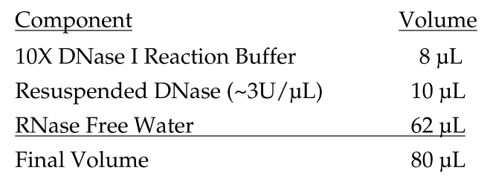
16. Add 350 μL Wash Buffer I to the Spin Cartridge containing the bound RNA. Centrifuge at 12,000 × g for 15 seconds at room temperature. Discard the flow-through and the Collection Tube. Place the Spin Cartridge into a new Collection Tube.
17. Add 80 μL PureLink ® DNase mixture (prepared as described above) directly onto the surface of the Spin Cartridge membrane.
18. Incubate at room temperature for <15 minutes.
19. Add 350 μL Wash Buffer I to the Spin Cartridge. Centrifuge at 12,000 x g for 15 seconds at room temperature. Discard flow-through and the Collection Tube and insert the Spin Cartridge into a new Collection Tube.
20. Add 500 μL Wash Buffer II with ethanol (page 11) to the Spin Cartridge.
21. Centrifuge at 12,000 × g for 15 seconds at room temperature. Discard the flow-through, and reinsert the Spin Cartridge in the same Collection Tube.
22. Repeat Steps 20-21 once.
23. Centrifuge the Spin Cartridge at 12,000 × g for 1 minute at room temperature to dry the membrane with attached RNA. Discard the Collection Tube and insert the Spin Cartridge into a Recovery Tube.
24. Add 100 μL RNase-Free Water to the center of the Spin Cartridge.
25. Incubate at room temperature for 1 minute.
26. Centrifuge for 2 minutes at ≥12,000 × g at room temperature.
27. Proceed to analyzing RNA Yield and Quality (Nanodrop and TapeStation).